**Module-5) Se - Introduction To Dbms Assessment**

**● Write SQL query to solve the problem given below:-**

**CREATE DATABASE Table**

**Create Cutomer Table**

CREATE TABLE Customer (

customer_id INT PRIMARY KEY,

cust_name VARCHAR(100),

city VARCHAR(100),

grade INT,

salesman_id INT

FOREIGN KEY (salesman _id) REFERENCES Sales(salesman_id)

);

**Create Sales Table**

CREATE TABLE Sales (

salesman_id INT PRIMARY KEY,

name VARCHAR(100),

city VARCHAR(100),

commission FLOAT (5, 2)

);

**INSERT Customer Data**

INSERT INTO Customer (customer_id, cust_name, city, grade, salesman_id)

VALUES (3002, 'Nick Rimando', 'New York', 100, 5001),

(3007, 'Brad Davis', 'New York', 200, 5001),

(3005, 'Graham Zusi', 'California', 200, 5002),

(3008, 'Julian Green', 'London', 300, 5002),

(3004, 'Fabian Johnson', 'Paris', 300, 5006),

(3009, 'Geoff Cameron', 'Berlin', 100, 5003),

(3003, 'Jozy Altidore', 'Moscow', 200, 5007),

(3001, 'Brad Guzan', 'London',100 , 5005);

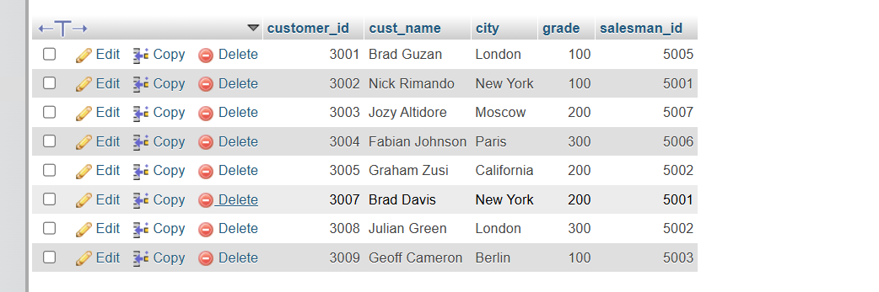

**INSERT Sales Data**

INSERT INTO Sales (salesman_id, name, city, commission)

VALUES

(5001, 'James Hoog', 'New York', 0.15),

(5002, 'Nail Knite', 'Paris', 0.13),

(5005, 'Pit Alex', 'London', 0.11),

(5006, 'Mc Lyon', 'Paris', 0.14),

(5007, 'Paul Adam', 'Rome', 0.13),

(5003, 'Lauson Hen', 'San Jose', 0.12);

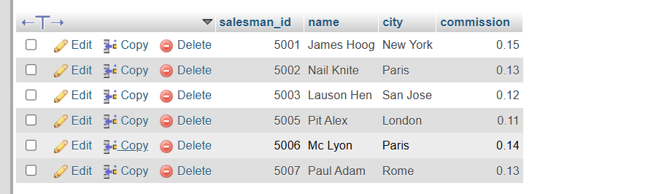

**SQL Query to Join Data**

SELECT

C.cust_name AS "Customer Name",

C.city AS "City",

S.name AS "Salesman",

S.commission AS "Commission"

FROM

Customer C

JOIN

Sales S

ON

C.salesman_id = S.salesman_id;

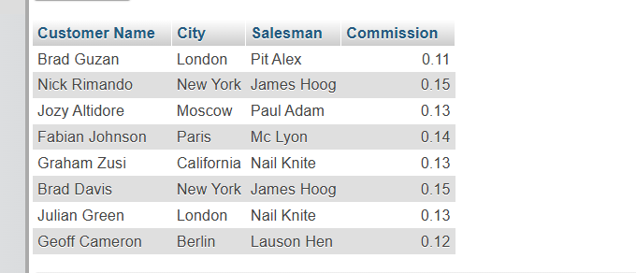

---------------------------------------------------END------------------------------------------------------------------